How to Submit Your work to Canvas

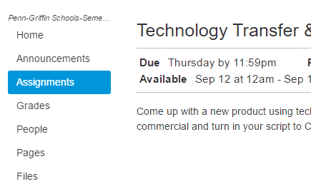

Go to Canvas and Click on Assignments

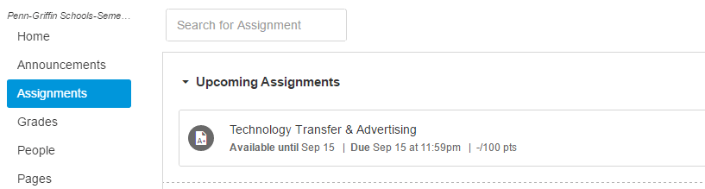

Find the Assignment you are looking for.

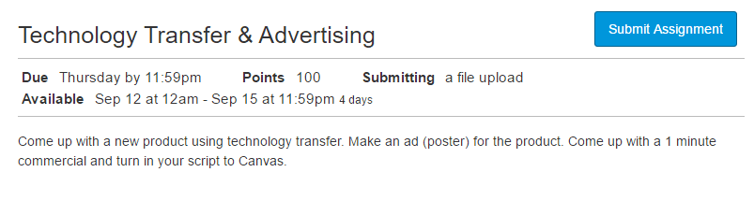

Click the Submit Assignment button.

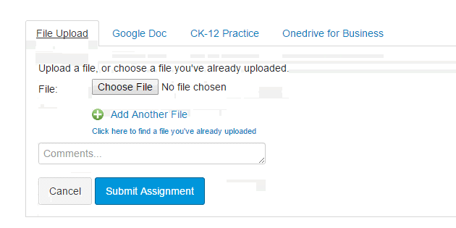

Click the Choose File button

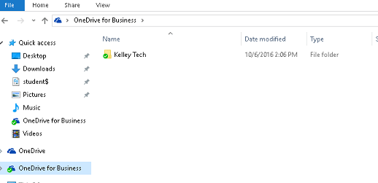

1st Click on OneDrive for Business

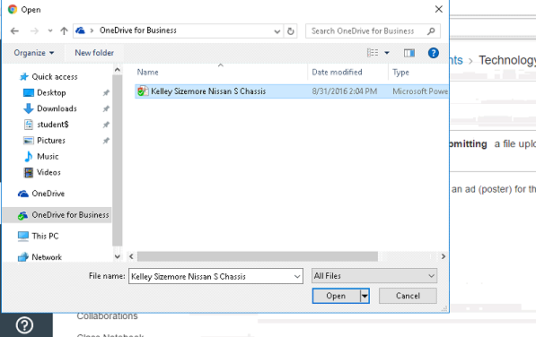

Find your work in your Tech Folder. Click on the file and click Open

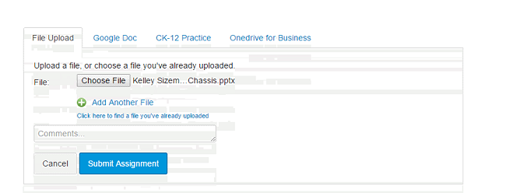

Once the File has uploaded Click Submit Assignment